**Integrating Jenkins and Urban Code Deploy**

Many teams use jenkins for continous integration, but need to coordinate the deployment of builds through environmnets. They will use jenkins to create those builds,and pass new builds to IBM urbancode Deploy for deployment. optionally, builds may be automatically deployed to a test environment.

**Prerequisites:**

To push the artifacts`from Jenkins to UCD, we need a service account.

To create a service account in UCD for an application to integrate the Urban Code deploy with Jenkins CI server, Please fill & share the below details and get the BAND - E approval from the permanant employee.

A new UCD service Account can be requested by submitting a Jira support ticket with required information.

(Please make sure you fill in this table before submitting your Jira support ticket so that we can make your engagement process as smooth as possible)

|  |  |  |
| --- | --- | --- |
| Service Account Creation (Information required) | Please fill in the below | Description |
| Service Account ID |  | The naming convention for a Service Account ID is as follows: Service Account name should always start with SRVUCD.  SRVUCD * < Team Name /Application Name> * <Role Name> e.g. SRVUCDTeamNameBuildMgr  NB: We prefer you to use your Team Name where possible. If you're not sure what your Service Account ID should look like, please provide your Team Name as it appears in UCD so that one of the Hub team can generate it for you. |
| Contact Distribution List |  | This contact DL will be used for distributing new tokens or issues with this ID/token |
| Quarterly re- certification Approver   * Name * File-d |  | Approver needs to be  1. Permanent employee  2. Band E and above |
| Jenkins/CI details |  | URL of where this ID will be used |
| Short Description |  | Short description of what this token will be used for |

**DETAILS AND IMPLEMENTATION GUIDANCE**

1. Acquire Jenkins Publisher plugin from Dev Tools Drive: \\Global.lloydstsb.com\file2\DML\SHARED\DigitalDevTools\Jenkins_plugins\ucdPublisher

a. Open the website of your Jenkins server.

b. Click on Manage Jenkins.

c. Click on Manage Plugins.

d. Open the Advanced tab.

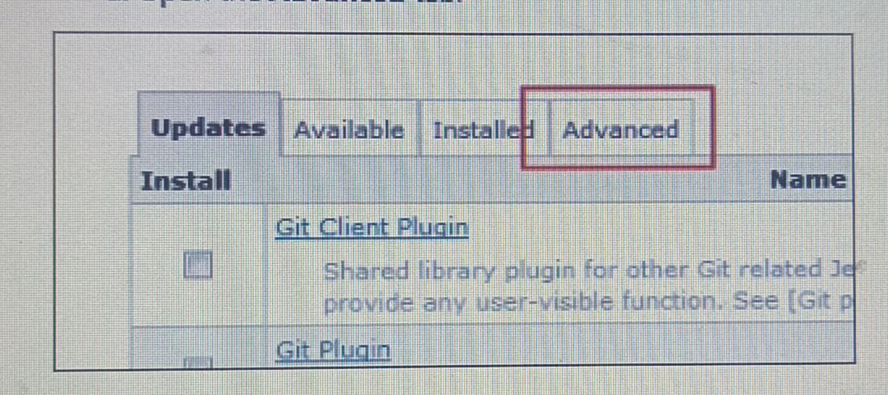

e. Click on ***Browse*** In the section ***Upload Plugin***.

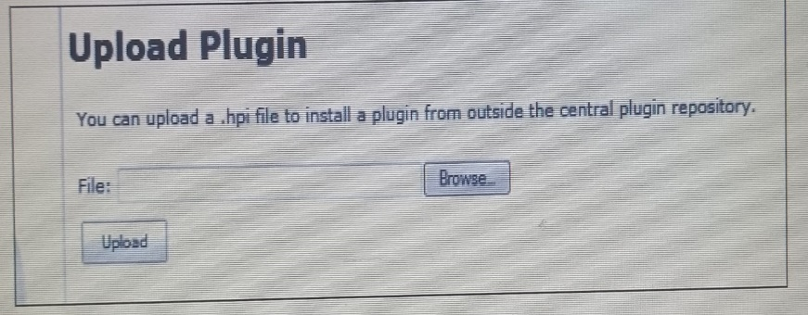

6. Select ***ibm-ucdeploy-publisher.hpi***. Click **Upload**.

7. Restart your Jenkins server in order to see the new plug-in by using http://jenkins-server:8080/safeRestart

8. Verify that the plug-in is installed and enabled

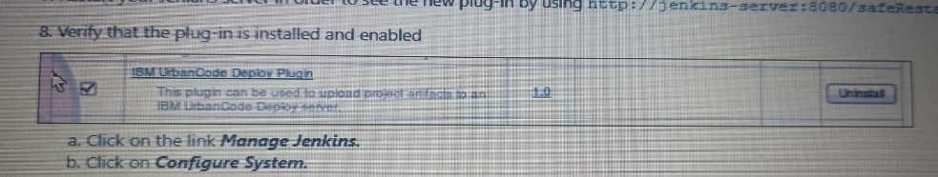

a. Click on the link **Manage Jenkins.**

b. Click on **Configure System**.

c. Add a profile for your Urban Code Deploy server For example, where

• **Profile Name** is ucd.intranet.group (as you wish)

• **IBM Urban Code Deploy URL** is https://ucd.intranet.group/

• **User name** is "PasswordisAuthToken" (note: especially because the post-build action may trigger a deployment, you should only use an account that can not deploy to secure environments like production. Creating a service account like "PasswordisAuthToken" within Urban Code Deploy is recommended).

• **Password** is Urban Code Deploy user's (Authtoken) password

d. Click ***Test connection*** to verify the configuration and click ***Apply.***

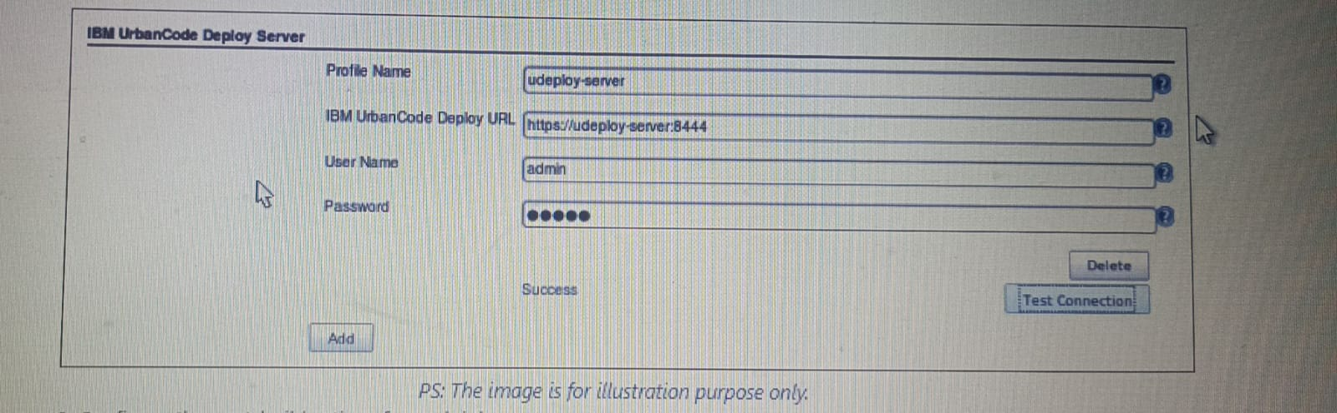

9. Configure the post-build actions for each job.

i. Select the task **Publish artifacts to IBM UrbanCode Deploy** in the section **Post-build Actions**

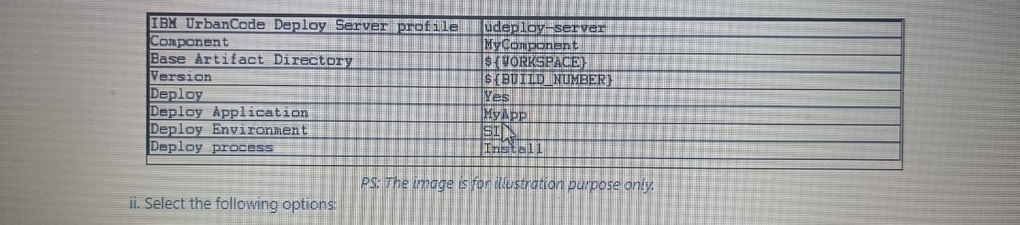ii. Select the following options:

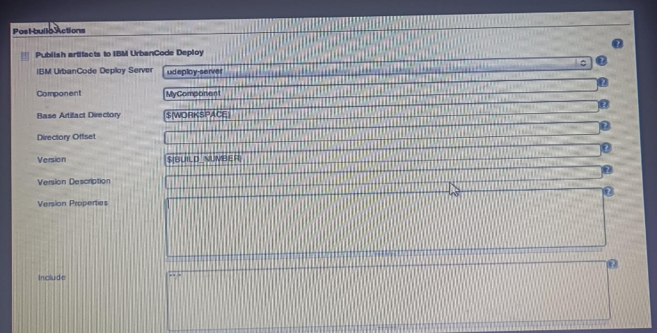

iii. Click ***Save***:

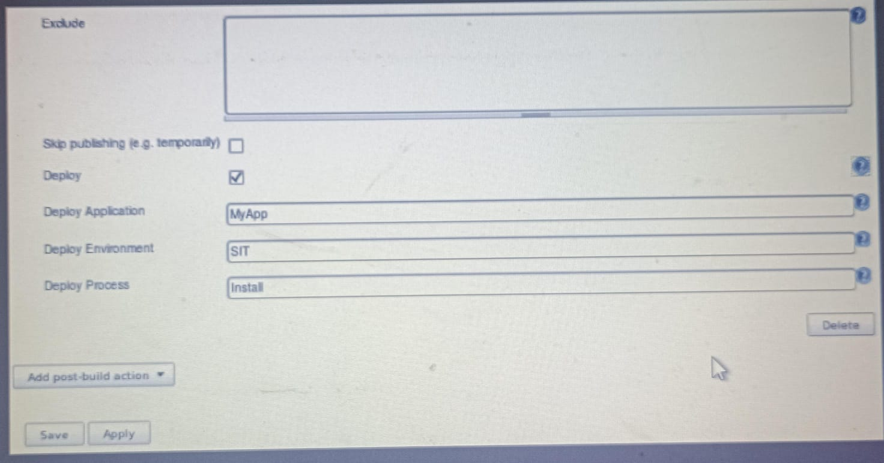

10. Click on the button ***Build No.***